AWAKEN SLEEPING ASSETS PROJECT
Evaluation Report Dynamic Service Times – Stockholm
(automated, unchecked Translation)

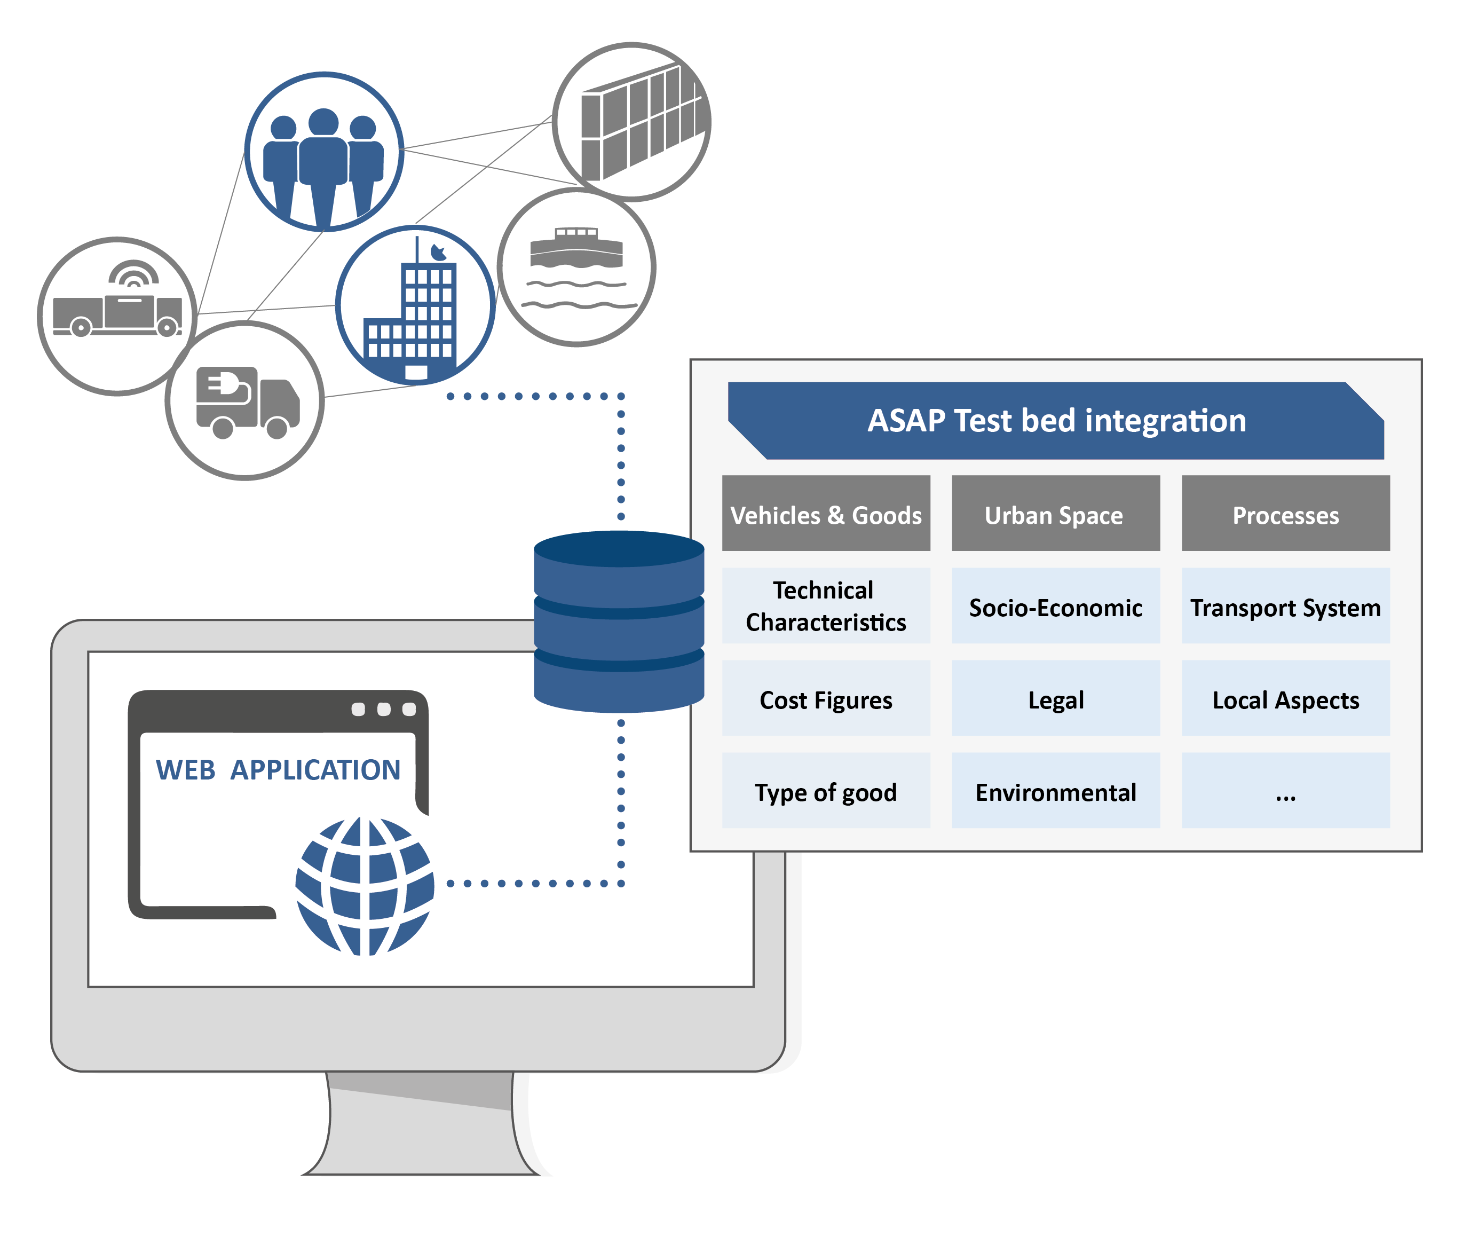

Grant agreement no: | No 875022
Project acronym: | ASAP
Project title: | Awaken Sleeping Assets Project

Evaluation Report Dynamic Service Times – Stockholm
(automated, unchecked Translation)

Start date of the action | 01.04.2021 | Duration: | 36 months
End date of the action | 31.03.2024
 |  | Version: | V1
Due date | Not applicable | Prepared by: | Jessica Danielsson
 |  | Checked by: | Paul Fenton
Project coordinator | Patrick Hirsch
 |  | Status: | final
 |  | Dissemination level: | PU
www.smarturbanlogistics.eu

Project partners

Organisation | Country
University of Natural Resources and Life Sciences, Vienna | BOKU | AUSTRIA
h2 projekt.beratung KG | h2pro | AUSTRIA
Fraunhofer Institut für Materialfluss und Logistik | FHG | GERMANY
Freie und Hansestadt Hamburg  Behörde für Wirtschaft und Innovation |Hamburg | GERMANY
Incharge GmbH | incharge | GERMANY
Association pour la Recherche et le Developement des Methodes et Processus Industriels - Centre de Gestion Scientifique | ARMINES | FRANCE
L'agence mobile de messagerie ecolologique | Fluids | FRANCE
Orange S.A | Orange | FRANCE
Stockholms stad | Stockholm | SWEDEN
Stockholm Vatten och Avfall | SVOA | SWEDEN

Document history

Date | Person | Action
30 jan 24 | Jessica Danielsson | First version
09.02.24 | Susanne Wrighton | Automated translation EN

Disclaimer
Any dissemination of results reflects only the author’s view and the European Commission and JPI Urban Europe is not responsible for any use that may be made of the information it contains.

Table of Content

Disclaimer 3

1 Introduction 5

Legal Conditions 6

Choice of Location 7

Concept 7

Pilot before pilot 8

2 Methode 9

2.1 Occupancy surveys 9

2.2 Survey 9
Survey Questopms 9

2.3 Workshop 10

3. Results 10

3.1 The utilisation rate of parking spaces is improved either by parked cars or by other uses of the space. 11

3.2 User experience regarding the level of service and availability of parking is improved for the citizens. 13
Evolution of Survey Responses 13
Summary, including suggestions for improvement 18

3.3 User experience of the level of service and accessible parking is improved among citizens. 18

3.4 Potential for an economically justifiable solution in a possible scale-up in comparison with the benefits that can be delivered. 19

3.5 The total service time is reduced and the service utilises most of the available service time. 20

3.6 Service level of contractors remains unchanged 21

3.7 The workload of the office and contractors remains unchanged or is justified with benefits if it is increased and the technical solution works for the purpose of the project. 21

3.8 An implementation of dynamic service times is possible 22
Planning and administration 22
System support and technology 22
Legal challenges 23

4. Discussion 23

5. Summary and conclusion 24

1 Introduction

In 2020, the Traffic Office, together with the Environmental Administration, SVOA and other cities, industries and research partners in Europe, applied for an EU project (ASAP - Awakening sleeping assets project) within the EUNAC EraNet Urban Accessibility and Connectivity programme. The project was granted with a start in 2021. In the project, 13 existing test beds will be evaluated and 11 new test beds will be tested. One of the new test beds is Dynamic Service Times in Stockholm.

Today, service times (one day a week when parking is prohibited between certain times) exist around the city in different constellations to enable contractors to carry out their work on the city's streets. This can be anything from changing light fittings, facade renovations to snow removal and sweeping. These service times are static and are not always used optimally, which is significant in a city where public space is limited. Implementing dynamic use of service times can lead to more efficient use of public space and leave room for other uses of the space when it is not currently used by the contractors. This can also lead to better accessibility of e.g. car parks.

The aim of the project is to test dynamic service times in order to investigate the legal, technical, user behavioural and economic aspects of dynamic service times. The project analyses the effectiveness of dynamic service times compared to the regular static service times. At the same time, tests of behaviour and acceptance aspects when introducing dynamic service times (for different relevant target groups such as citizens and companies) will be carried out. In the case study, the regulations and costs associated with the introduction of dynamic service times will also be analysed and balanced against the costs of static service times. The project will answer:

- What are the legal possibilities and obstacles to dynamic service times?
- How can dynamic service times enable a much better use of space in the city?
- How can the city be organised in terms of dynamic service times?
- Are dynamic service times economically viable?
- Finally: Are dynamic service times interesting to implement?

In general, dynamic service times can enable citizens, businesses and visitors to have more opportunities to park or use public space in other ways. This is because dynamic service times would enable more efficient use of public space. While the main goal is to improve life for citizens, the project can also potentially enable better monitoring of the contractors who use the service times today. Also the effect on wrongly parked vehicles can have a positive impact on the contractors.

The project also contributes to the transition to a resource-efficient and sustainable transportsystems in the city and contributes to global sustainability goal 11. Sustainable cities and communities and in particular targets 11.6 and 11.3.

Legal Conditions
A fundamental prerequisite for the pilot was that it should be legally possible to establish the traffic regulation, the local traffic ordinance, and that it should be possible to mark the traffic regulation with a valid road sign.
To investigate this, the project produced a report to review the legal possibilities for implementing the pilot. The conclusion of the investigation was that there are no legal obstacles to writing a local traffic ordinance dynamically or using a road sign that lights up when needed.
The local traffic ordinance is a deviation from the general provisions of the traffic regulations. The traffic regulations give the municipality the opportunity to regulate based on the conditions applicable to the specific location within the conditions provided by the traffic regulations. Therefore, the traffic ordinance should describe what should apply at the location and when it should apply. In other words, the ordinance should be able to indicate under what conditions the dynamic regulation should apply. It must therefore be stated in the ordinance under what conditions the service time will apply. The investigation therefore concluded to formulate the parking prohibition as follows but that the time needed to be adjusted to the service time of the pilot street on Wednesday 8-16:
However, parking is prohibited on Wednesdays during the time between 00:00 - 06:00 when road maintenance is underway.
Road maintenance work is defined according to the legal framework of road maintenance issued by the Swedish Association of Local Authorities and Regions (SKR) as "all measures taken concerning streets and roads. It primarily involves the construction, operation, and maintenance of streets and roads." (Persson, G. 2018. Road Maintenance Law [Fifth Edition]. Stockholm: Swedish Association of Local Authorities and Regions. p.6).
In dynamic regulation, it becomes a requirement to document when and why the parking ban was in effect. It must therefore be documented when road maintenance work occurres at the site and what type of road maintenance work is being conducted.

The formulation implies that the parking ban only applies when road maintenance work is ongoing. One consequence of this is that if the sign is lit up and no road maintenance work is taking place, there is no support for the parking ban. This could potentially invalidate any parking citations.
The legal investigation concluded that to mark a temporary prohibition, it has to be marked out as far in advance as one would normally be allowed to park at the location. This means that if parking is allowed at the location for 24 hours, the parking ban must be marked out 24 hours before it takes effect. This factor makes a dynamic service time incompatible with the city's residential parking. The residential parking conditions in Stockholm state that vehicles have the right to park for a maximum of seven days, which means that a temporary parking ban must be marked out seven days in advance. Since the marking is done by specifying the day of the week and not the date when road maintenance work will take place, it will not be possible to mark out the dynamic service day in time since it will not be known which Wednesday is referred to.

The correct term for signs according to the road sign regulations is road sign, which means that the road sign used for the service time is a dynamic road sign. However, since sign is a more commonly used term for road signs, we will continue to refer to the dynamic road sign as a dynamic sign.

Choice of Location
The main criteria that the site needed to fulfil were:
- It would be street land.
- It should not be a class 1 street for winter road maintenance.
- It should be a year-round service.
- It should be a daytime service.
- It would not be a Monday street.
- There would be on-street parking.
- It would not be resident parking.
- No more than one sign would be used.

Based on the above criteria, Ingenjörsgatan was chosen as the pilot street. Ingenjörsgatan is a class 2 street for winter road maintenance, which means that road maintenance work occurs relatively frequently but not every week. A class 1 street has higher traffic volumes and is in greater need of ongoing maintenance. By choosing a class 2 street, any potential issues with the dynamic sign would not have as significant consequences for traffic safety.
The street has service times throughout the year on Wednesdays. The reason it was important not to have a Monday street was to ensure that all legal requirements for the dynamic sign could be met. It was also important to have daytime service as freed parking time has the greatest impact.
An important factor in choosing Ingenjörsgatan was that there is no residential parking in the area, as the pilot could not be reconciled with the conditions of the residential parking system.

Concept
The concept for notifying the use of dynamic service days was formed with the principle that the traffic office contacts all functions identified as regularly needing to perform road maintenance work before each service day. If any of these functions require the service day, the parking ban will apply. If none of them require the service day, parking will be allowed instead.
The functions regularly assessed to perform road maintenance work and utilize the service day were:
- Snow removal and ice control
- Maintenance sweeping and weed clearance
- Sand sweeping
- Drain cleaning
- Leaf collection
- TA plans
- Marking obligations
- Excavations
The traffic office contacted all functions via E-Mail before each service time, and the responsible contractor then had a certain time to respond if they needed to use the service time. A lack of response was counted as a negative response, and if no responses were received, the sign remained unlit, meaning the service time was not activated.
If the service day was needed, the dynamic sign would light up at least 24 hours before because it is visitor parking at the location. This was to ensure that everyone parking at the location according to current parking regulations had the opportunity to observe that there would be a parking ban at the location the following day.
After the designated response time, the designated responsible person at the traffic office would activate the sign if affirmative responses were received and log the received information for evaluation.
Early in the project, it was identified that during winter, the decision on the service day must be made as close to the service day as possible because the weather can change suddenly. However, the project also identified a need to test a model that could work on a larger scale and that would work with the city's residential parking system, if the conditions were revised, which would require longer lead times for the contractors. Therefore, it was decided that there would be two different types of pre-announcements during the project, one for winter and one for summer.
Winter:
During the period identified by the traffic office as winter from November 1st to May 15th, the pre-announcement was as follows:
The traffic office sent out a request for the use of the service day on Monday before 8 am. The recipients of the E-Mail had until Tuesday at 7 am to respond. If any of the contractors replied yes, the sign would be lit up on Tuesday at 8 am through an automatic scheduling in the system that handles the activation and deactivation of the dynamic sign. This meant that the sign would light up 24 hours before the service day began. When the service day ended on Wednesday at 4 pm, the dynamic sign would be turned off.
If no contractor needed the service day, an employee from the traffic office would go in and remove the scheduling for the activation of the dynamic sign before 8:00 am on Tuesday. This way, the parking ban would not be visible, and parking would be allowed.
Summer:
During the period identified by the traffic office as summer from May 16th to October 31st, the pre-announcement was as follows:
The traffic office sent out a request for the use of the service day on Monday before 8 am the week before the service day. The recipients of the E-Mail had until Wednesday at 12 pm to respond. If any of the contractors replied yes, the sign would be lit up on Wednesday at 4 pm the week before the service day through an automatic scheduling in the system that handles the activation and deactivation of the dynamic sign. This meant that the sign would light up a week before the service day began. When the service day ended on Wednesday at 4 pm, the sign would be turned off.
If no contractor needed the service day, an employee from the traffic office would go in and remove the scheduling for the activation of the dynamic sign before 4:00 pm on Wednesday the week before the service day. This way, the parking ban would not be visible, and parking would be allowed.

Pilot before pilot
Before the implementation of the pilot, a need was identified to conduct a "Pilot before Pilot." The purpose of Pilot before Pilot was to ensure that the communication channels within the traffic office and between the traffic office and its contractors were functioning. The test involved sending out a request according to the concept every week, and the response from the contractors was saved, just as during the planned pilot. Pilot before Pilot tested both how the concept for notification during winter would work, where there was a shorter time span to respond, and how Pilot before Pilot with a longer time to respond and longer lead time to the service day would work.
Pilot before Pilot also aimed to provide an indication of how often the service day would be needed during the pilot and took place between March 14th and June 10th, 2023.

The results of Pilot before Pilot showed that the service time was used for 4 out of 12 weeks, resulting in a utilization rate of 33%. The conclusions of Pilot before Pilot were that an automated system is necessary for scaling up to multiple streets. During the pilot before the pilot, it was also noted that for scaling up to be possible, a technical solution is needed where the dynamic sign can be powered by battery or solar panel.

2 Methode

2.1 Occupancy surveys
Occupancy surveys to investigate how many parked cars were parked in the area were conducted three times during the project. The pavement surveys were carried out with the assistance of parking attendants who counted the number of cars parked on each street. The occupancy was then measured by dividing the number of parked vehicles by the estimated number of parking spaces along the stretch (number of parkable meters / 6 meters).

2.2 Survey

Survey Questopms
The survey consisted of 20 questions. Thirteen of the questions had predefined response options and the rest of the questions could be answered using free text. Some questions had mandatory answers while others were optional. This means that the response rate between questions varied. Some of the questions consisted of an associated question where the participant could leave a comment on their predefined answer option. The questions, which can be divided into different categories, were as follows:

  - Participant’s habits
1. Do you live in the city of Stockholm?
2. Do you usually drive a car in Stockholm City?
3. Do you usually park on the street?

  - Participant’s view on service times
4. Do you know about service times and why they exist?
5. What do you think about service times?
6. What do you think is positive about service times?
7. What do you think is negative about service times?
8. Is there anything else you would like to add? Positive or negative.

  - Clarity and appearance of the digital signage
9. What do you think about having a digital sign for service times?
10. Is there anything else you would like to add?
11. Do you think the digital sign is visible?
12. Is there anything else you would like to add?
13. The white sign contains the text:
When the sign is lit: no parking Wednesdays 8-16 pm 16 May - 31 Oct: the sign is lit on Thursdays at 8 am. 1 Nov - 15 May: the sign is lit on Tuesdays at 8am.
Do you think the text is understandable and clear?
14. Do you have any suggestions on how the sign could be made clearer?

  - Function of the digital signage
15. During the winter period 1 November - 15 May, the sign is lit 24 hours before the parking ban comes into force. This is to allow for snow removal if necessary. Do you think this time is sufficient?
16. During the summer months from 16 May to 31 October, the sign is illuminated six days before the parking ban comes into force. Do you think this time is sufficient?
17. Is there anything else you would like to add?

  - Suggestions for improvment
18. If the city were to make greater use of dynamic service times, how would you prefer to receive the information?
19. Is there anything else you would like to add?
20. Do you have any other ideas for the development of service time in addition to ongoing trials?

2.3 Workshop
Halfway through the project's implementation phase, a workshop was held with relevant stakeholders. The purpose of the workshop was to gather thoughts, experiences, and perspectives to consider for future scaling.

The workshop consisted of a series of consecutive group exercises aimed at both identifying improvements regarding methods, technology, systems, and similar aspects that the group saw, and getting an understanding of how these various improvements were perceived in relation to each other.

The starting questions that the workshop was based on were:
What is needed for dynamic service times to function on a large scale?
- from a system perspective?
- from an organizational perspective?

Several different areas of development emerged, and the 5 most important, in order of priority, are:
- Operations/production
- Notification system
- Integration with internal systems
- Design of signage
- General regulations

3. Results
In the document "ASAP - Dynamic Service Times Implementation Plan Pilot," a number of factors were defined that would constitute a successful pilot. These factors were:
The utilization rate of parking spaces improves either through parked cars or through other use of the space.
The proportion of illegally parked vehicles improves or remains unchanged.
User experience regarding service level and available parking improves among citizens.
The total service time is reduced, and the service utilizes a larger portion of the available service time.
The service level among contractors remains unchanged.
The workload at the office and among contractors remains unchanged or is incentivized with benefits if increased.
The technical solution works for the purpose of the project.
Potential for an economically viable solution in the event of scaling up compared to the benefits that may be delivered.
In order to evaluate the pilot in the best possible way, various types of data were collected before, during, and after the pilot. The evaluation then provided an indication of whether dynamic service times are something the city should further investigate or interesting to implement or not. The results of the data collection will be presented below based on the factors defined for a successful pilot.
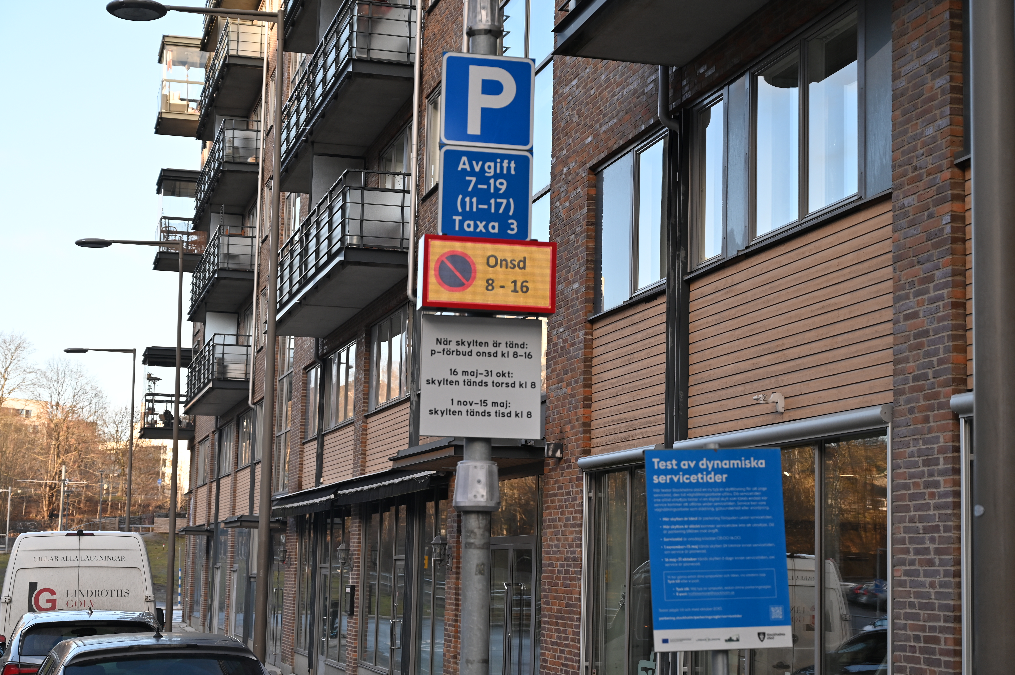
Picture: Sam Victorin, Stockholms Stad

3.1 The utilisation rate of parking spaces is improved either by parked cars or by other uses of the space.
This pilot project had several purposes. One of these was to investigate how the utilization rate of parking spaces on the pilot street and surrounding streets was affected by the service time and dynamic signage. The hypothesis was that dynamic signage increases the occupancy on the pilot street on Wednesdays when the sign is turned off (and parking is therefore allowed).

To calculate the utilization rate of parking spaces within the area, the number of vehicles was inventoried by parking attendants over a total of 9 weekdays. First, during 4 weekdays in August/September 2022, where two of these days were Wednesdays when most streets in the area had service time and during two other weekdays. When the dynamic sign was installed, the number of vehicles was then inventoried again over 4 weekdays during March/April 2023. However, the dynamic sign was illuminated on these service days, which meant that parking was not allowed on the pilot street. Finally, one day was inventoried in September 2023, this time the dynamic sign was turned off, and parking was allowed on the pilot street. The number of parking spaces per street was calculated by the traffic office assuming that an average parking space is 6 meters. To report the utilization rate in percentage, the number of parked vehicles was divided by the capacity, the number of parking spaces on each street within the area. Separate figures are presented for the pilot street and surrounding streets.
On the pilot street, Wednesday is the service day. Table 1 shows that the occupancy on the pilot street during a non-service day varied between 25 – 88%. It also shows that the parking bans during the service time were generally respected, with 3 out of 4 days with parking bans having 0 parked cars during the inventory. Only on August 31st was there a difference with 4 parked cars, which were then illegally parked. The table also shows that on all days except Wednesdays, there are parked cars. It is interesting to note that no cars are parked on the pilot street on April 5, 2023, even though parking is allowed thanks to dynamic signage. The table also shows that on Wednesday, September 27, 2023, there were 3 parked vehicles. Even on this day, the dynamic signage allowed parking. Although this dataset is small and should be seen as a sample, it is still possible, thanks to the parked cars on September 27, to see that the dynamic signage increased the utilization rate of parking spaces on the pilot street.

Tabell 1. Beläggningsgrad på pilotgatan. Tabellen visar totalt antal p-platser samt de begränsade antalet p-platser som är tillgängliga för parkering p.g.a. servicetid. Gul markering indikerar servicedag där servicetiden ej utnyttjades, dvs parkering var tillåten.
 | Tue  30/8-22 | Wed  31/8-22 | Wed 7/10-22 | Thu 8/10-22 | Wed  29/3-23 | Thu 30/3-23 | Wed  5/4-23 | Thu  5/5-23 | Wed  27/9-23
Total number of parking spaces | 8 | 8 | 8 | 8 | 8 | 8 | 8 | 8 | 8
Number of available parking spaces | 8 | 0 | 0 | 8 | 0 | 8 | 8 | 0 | 8
Cars parked | 7 | 4 | 0 | 2 | 0 | 6 | 0 | 5 | 3
Occupancy rate | 88% | 50% | 0% | 25% | 0% | 75% | 0% | 63% | 38%

Table 2 shows the occupancy on surrounding streets, also inventoried by parking attendants. The total number of parking spaces on the surrounding streets is 96. However, due to the service time, the available parking spaces vary between 33 and 89. Looking at the occupancy rate for the same days as for the pilot street, the occupancy rate varies between 27 – 60% of the total number of parking spaces, which is 96. Comparing subsequent days with each other, it can be observed that the occupancy rate is generally higher on days when more parking spaces are available within the area. However, the situation becomes different if we make a corresponding analysis considering the reduced number of parking spaces due to service times. Then, the occupancy ranges from 42-145%, where values over 100% indicate that the number of parked vehicles exceeds the available spaces in the area. It is evident that the available parking spaces are simply too few on several Wednesdays during service time when only 33 spaces are available. It is also noted that on the occasion when the sign on the pilot street is turned off (and parking is allowed), there were 31 parked cars and the number of available parking spaces was 33. On the same day, 3 cars were parked on the pilot street; if these cars were not allowed to park there that day, they would likely have parked on one of the surrounding streets, causing the occupancy on the surrounding streets to exceed 100%. In other words, the dynamic service time possibly prevented the occupancy rate on the surrounding streets from exceeding 100% on September 27th.

It is also interesting to note that problems with overcrowding do not occur on Tuesdays and Thursdays. This is likely due to the fact that the number of available parking spaces is higher than on Wednesdays. To achieve a more even occupancy rate of parking spaces, a dynamic service time could be complemented by reviewing the schedule for service time so that the number of available parking spaces in the same area does not vary as much between days.

Table 2 Occupancy rate on surrounding streets. The table shows the total number of parking spaces as well as the limited number of parking spaces available for parking due to service time. Yellow highlighting indicates a service day where the service time was not utilized, i.e., parking was allowed on the pilot street (note! only on the pilot street, not on these surrounding streets).
 | Tue  30/8-22 | Wed  31/8-22 | Thu 7/10-22 | Thu  8/10-22 | Wed  29/3-23 | Thu 30/3-23 | Wed  5/4-23 | Thu  5/5-23 | Wed  27/9-23
Total number of parking spaces | 96 | 96 | 96 | 96 | 96 | 96 | 96 | 96 | 96
Number of available parking spaces | 77 | 33 | 33 | 89 | 33 | 89 | 33 | 89 | 33
Number of parked cars | 58 | 48 | 44 | 43 | 42 | 46 | 26 | 37 | 31
Occupancy rate | 60% | 50% | 46% | 45% | 44% | 48% | 27% | 39% | 32%
Occupancy rate considering service time | 75% | 145% | 133% | 48% | 127% | 52% | 79% | 42% | 94%

3.2 User experience regarding the level of service and availability of parking is improved for the citizens.
As part of this project, a digital survey was conducted with the aim of better understanding how actual users experienced the dynamic service time. Participants were made aware of the survey by QR code flyers distributed alongside parking. In this manner, a total of 64 responses were collected.

Evolution of Survey Responses
  - Participant’s habits
The majority of respondents live in Stockholm and usually drive a car in Stockholm. All respondents usually park on the street but it varies between whether the respondents use visitor parking or resident parking.
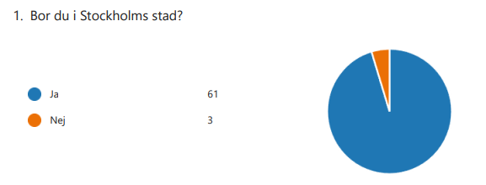
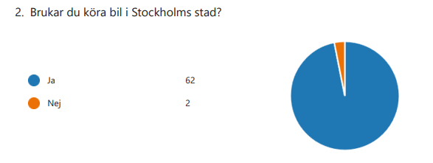
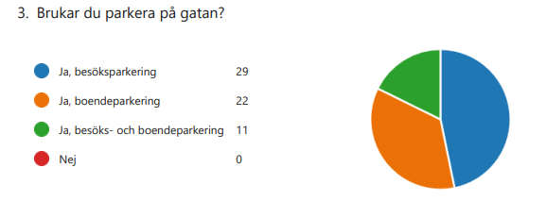

  - Participant’s view on service times
Nearly all participants are aware of service times and why they exist. This may seem positive for obtaining relevant responses to the survey. In question regarding the respondents' opinions on service times, the average rating was 3.02 on a scale of 1–5. The positive aspect of service times is considered to be that the signs are visible and clear. What is perceived as negative by the vast majority of respondents is how service times are utilized.
In question 8, participants could provide qualitative comments, and in summary, the negative comments revolved around whether the service time is actually utilized. Participants' experience is that the service time is not used at all, for example, when it has snowed, and it is perceived as negative to have to move their car when no service has been performed. It is also expressed that dynamic service times can create uncertainty about when parking bans actually apply. The positive comments revolve around participants appreciating when service is actually performed and that it is predictable when parking bans apply. Participants also see it as positive to actually have the opportunity to utilize parking spaces when no service is planned for the street.
The presence of negative expressions in the survey regarding how well service times are utilized justifies this pilot, as the goal of the pilot is to streamline and utilize the unused service times. At the same time, it emerges from the participants that dynamic service times can also create uncertainty about when the parking ban applies, which is an important message for any future implementation.

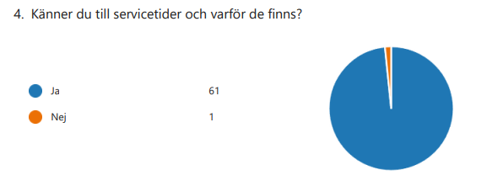
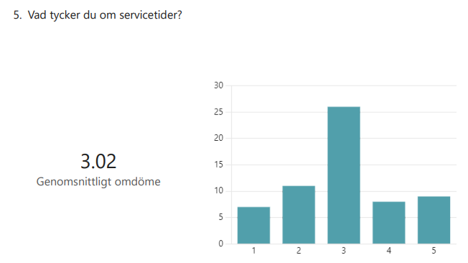

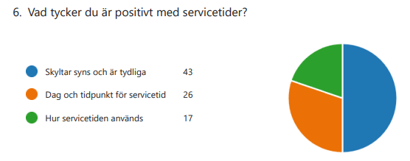
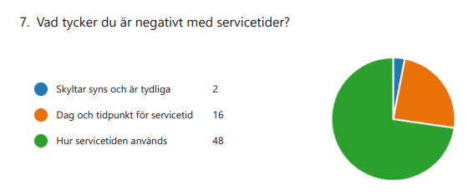

  - Clarity and appearance of the digital sign
Under question 9, participants were asked to rate their opinion of a digital sign on a scale of 1–5. The average response was 4.20, with the vast majority giving a rating of five. Participants were given the opportunity to add a comment to their response in question 10. Most of the positive comments revolved around participants preferring a digital sign because streets are cleaned as needed, and it feels smart and in line with the current technological development. There were also requests for the digital sign to be complemented with a phone application where users could subscribe to the dynamic information.

Several of those who left a comment emphasized the importance of the dynamic service time being predictable and highlighted difficulties in planning, such as for holiday trips. Participants do not want to risk parking their car when the sign is off, only to return to find that the digital parking sign has been activated while their car was unattended. There were also requests for a clearer or more contrasting sign, as the digital sign is perceived as difficult to see in sunny weather. It is also considered important to ensure how the digital sign operates during power outages.

Regarding the visibility of the digital sign, the average response was 4.54, with the vast majority rating it as four or five. In the free comments for this question, participants expressed positivity about digitization but stressed the need for improved information on the digital sign. There were concerns about what happens if the sign breaks down, experiences a power outage, or if the sign's message changes after the car has already been parked on the street. The suggestion of receiving information through a phone application or website to alleviate concerns about changes in the sign's message while the car is parked was also reiterated in this free comment section.
The preference for a digital sign expressed by participants, along with their acknowledgment of its alignment with current technological trends, is seen as positive and in line with the goals of this pilot.

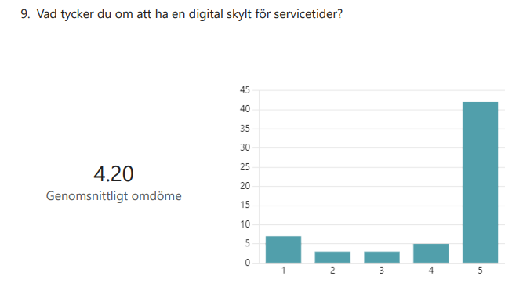

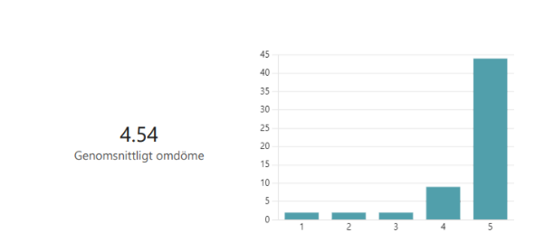

  - Function of the digital sign
The digital parking sign is accompanied by a fixed white sign that clarifies the function of the digital sign. It also contains information about when the sign will be activated for planned service. The average rating regarding the comprehensibility of the text on the fixed sign was 3.58. Many respondents gave a rating of five, but there were also variations between response options 1–4. Participants were also given the opportunity to write a comment on how the fixed sign could be made clearer. One prominent suggestion was that it might be beneficial to have the sign activated for the same duration before parking bans regardless of the time of year. This would make it easier to understand and reduce the risk of misunderstandings.

Many comments revolved around the information on the sign being unclear and the difficulty in knowing what applies at different times. Several participants stated that the fixed sign contributes to confusion about when the actual parking ban will take effect. One improvement suggestion is that the white sign could also be supplemented with more information in a parking app.
The digital sign is activated at different times depending on whether it is winter or summer, before the parking ban takes effect. This is because during the winter months, greater flexibility is required to quickly clear snow from the street when needed. During the winter, the sign is planned to be activated 24 hours before the snow removal service time. During the summer, the service times are estimated to be able to be performed with six days' notice before the parking ban takes effect. In the survey, participants were asked if they thought the duration for how long the sign would be activated before a parking ban was sufficient. During the winter, about 66% of respondents think that one day is sufficient. During the summer, about 85% think that six days is sufficient to keep the sign activated before a parking ban takes effect.

In the free comment field for the questions, important points emerge about how when service is to be performed on the street, it should always be on fixed days, and information should also be provided through other channels. The uncertainty about which day and time the sign will be activated when one's car is already parked is also prominent in this question. Comments are made about whether service times are even needed during the summer, as it is also a time when many are already away and prefer to have their car parked for a longer period without having to keep track of it.

An important lesson to take away for a potential implementation is precisely what participants express regarding question 13 in the survey. Allowing the sign to be activated at different times for a potential parking ban can create confusion, and people do not dare to "take a chance" with parking their vehicle. It is worth considering whether it is possible to have the dynamic sign activated at the same time regardless of the time of year, solely to avoid confusion. From this perspective, the dynamic sign could also be supplemented by a digital tool to inform interested vehicle owners that the sign is activated.

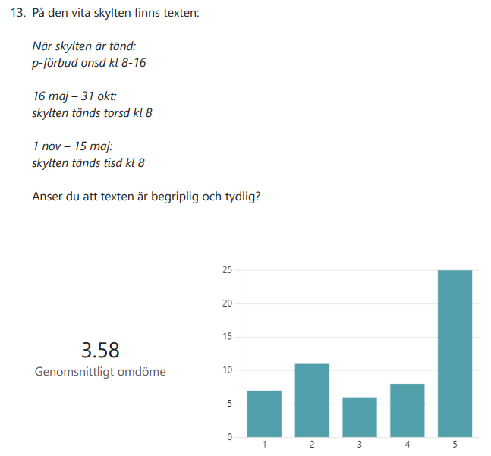

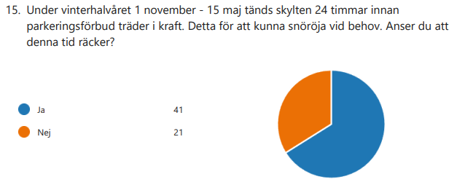

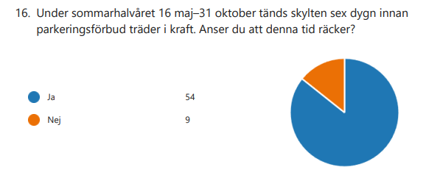

Summary, including suggestions for improvement
In summary, participants' positive opinions about the dynamic sign revolve around the opportunity to park on a street that otherwise isn't utilized, aligning with the ongoing technological advancements and digitalization in society. If the city begins to use dynamic service times more extensively, most participants prefer to receive information both through a digital sign on-site and digitally via a website or app. Several participants have commented that they would like to receive information via SMS, notifications, website, or app on their phones, as it would simplify planning and reduce the need to keep track of their parked vehicle. Throughout the survey, there is a recurring suggestion about how information can be supplemented in various ways.

Participants were also asked to provide comments on whether they would like to add information to the project. Responses include requests for more residential parking spaces, the opportunity to park for longer periods, and clearer markings. The price of parking is also mentioned as not corresponding to the service that vehicle owners desire. This is interesting because parking is already heavily subsidized, and after the survey, residential parking in the area has been increased. However, responses regarding pricing may only reflect participants' expectations of what a paid parking space should entail in terms of service and amenities.

One comment suggests the idea of a QR code that interprets the digital sign and provides information on whether one can park and for how long. It's worth noting that such an application already exists in the App Store, and participants' lack of awareness of the application might indicate that such applications need more visibility and accessibility. There are also requests for the digital sign to be turned off the same day once the service is completed. Several participants have also expressed positive views on dynamic service times, seeing it as a step in the right direction, and wish to apply the same method to other parking areas within the city of Stockholm.

3.3 User experience of the level of service and accessible parking is improved among citizens.
I order to better understand how service times, as well as dynamic signage, affect illegal parking in the area, analyses were conducted based on data from PASS – a register for parking violations. Data from the pilot period, November 23, 2022, to August 31, 2023, was analyzed and compared with the corresponding period starting a year earlier, i.e., November 23, 2021, to August 31, 2022. Complete PASS data were available for these periods. The number of issued parking fines was compiled, as well as the average per weekday for both the pilot street and the surrounding streets.

Overall, it can be observed that the number of fines on the pilot street is relatively low. Before the pilot, 37 parking fines were issued on the pilot street, averaging 0.93 per week (Table 3). During the corresponding period of the pilot, 32 fines were issued, or 0.80 per week. The number of parking fines decreased during the pilot period. This aligns with the goal of improving or maintaining the proportion of illegally parked vehicles. However, looking at individual weekdays, we see that the number of parking fines increases on Wednesdays, which is the only day the dynamic sign applies. This may seem surprising since the dynamic signage during the pilot allowed parking on 75% of Wednesdays that would otherwise have had parking bans from 8 am to 4 pm. The reason for the increasing number of parking fines on Wednesdays is unclear, but it does not align with the goal of improving or maintaining the proportion of illegally parked vehicles; rather, it indicates the opposite.

Table 3 also shows parking fines for surrounding streets. We observe the same pattern for these streets; the total number of parking fines decreases during the pilot, while the number of parking fines on Wednesdays increases. It is clear that Wednesdays (with the fewest available parking spaces) are the weekday with the highest number of issued parking fines. This is followed by Tuesdays (with the second fewest available parking spaces).
We do not know the reason for the increase in parking fines on Wednesdays. Especially on the pilot street, we expected the number to decrease during the pilot. It cannot be ruled out that potentially changed routines among parking officers could have contributed to the somewhat surprising results on Wednesdays.

As Wednesday is the day with the fewest available parking spaces (due to service times) and the highest number of parking fines, the analysis also shows how service time generally seems to have a significant impact on the number of illegal parking in the area. This is consistent with the occupancy data collected by parking officers on selected dates (see earlier section). On service days, it is likely difficult to find an available parking space, resulting in illegal parking. If a dynamic service time were to be introduced for the entire area, the number of available parking spaces would be higher on days when no service is performed. This would make it easier to find an available parking space, which would likely affect the number of parking violations.

Table 3. Number of fines per weekday before (2021-11-23 - 2022-08-31), and during (2022-11-23 - 2023-08-31) the pilot period divided into the pilot street and surrounding streets. The figure in parentheses indicates the average number of fines per week.
 | Mon | Tue | Wed | Thu | Fri | Sat | Sun | Total
NUMBER OF FINES ON PILOT STREET BEFORE THE PILOT | 7 (0,175) | 4 (0,1) | 9 (0,225) | 5 (0,125) | 6 (0,15) | 6 (0,15) | 0 (0) | 37 (0.93)
NUMBER OF FINES ON THE PILOT STREET DURING THE PILOT | 5 (0,125) | 4 (0,1) | 14 (0,35) | 1 (0,025) | 3 (0,075) | 5 (0,125) | 0 | 32 (0.80)
NUMBER OF FINES ON NEIGHBOURING | 123 (3.075) | 200 (5.0) | 268 (6.7) | 150 (3.75) | 132 (3.3) | 136 (3.4) | 30 (0.75) | 1039 (25.98)
STREETS BEFORE THE PILOT | 130 (3.25) | 176 (4.4) | 286 (7.15) | 124 (3.1) | 110 (2.75) | 99 (2.475) | 28 (0.7) | 953 (23.83)

3.4 Potential for an economically justifiable solution in a possible scale-up in comparison with the benefits that can be delivered.
We have calculated the potential income in the form of parking fees generated by the pilot project over approximately 11 months (November 23, 2022 – October 31, 2023). The pilot street accommodates 8 parking spaces, and on a typical weekday, there is a parking fee of 15 SEK/hour for 12 hours per day. This means that the maximum income on the pilot street on a weekday is 1440 SEK (8 x 15 x 12 = 1440). During the pilot project, the dynamic signage allowed parking on the pilot street for 75% of Wednesdays that would otherwise have been service days.

Table 4 shows the maximum income from parking fees for one week before the pilot and one week during the pilot under the actual conditions where the dynamic signage allowed parking for 75% of the time that would otherwise have been designated as service time with parking prohibited. The maximum income from parking fees before the pilot was 6960 SEK per week, while during the pilot, the corresponding amount was 7680 SEK. The difference between these is 720 SEK. In other words, the pilot project increased the average maximum income from parking fees by 720 SEK per week, or the equivalent of 90 SEK per parking space. However, this figure should be seen as a theoretical value as it assumes 100% occupancy during all the times when parking is allowed during service days. In reality, the occupancy in this area is lower, as shown in previous sections.
It is difficult to scale this up to surrounding streets. In theory, the 96 parking spaces on the surrounding streets with dynamic signage could maximally increase the income from parking fees by an average of 90 SEK per parking space, or 96 x 90 = 8640 SEK total during an average week.

However, once again, this is just a theoretical value that requires 100% occupancy. Similarly, it is difficult to scale this up to the entire city. Logically, the city's economic income from parking tickets would only increase if the price per ticket increases or if the number of parking spaces in the city increases. Dynamic service times contribute to more parking spaces per day in the city, influencing where people choose to park. However, the dynamic signage itself does not automatically contribute to more cars and more parking spaces when looking at a larger area or a whole city. Therefore, the income from parking fees may be expected to remain roughly the same even if dynamic signage were implemented on a large scale. However, potentially, the improved opportunities to find a parking space could lead to more people in the city choosing to acquire a car or park their car in the city. Only then would dynamic signage likely contribute to increased income from parking fees. Furthermore, in a cost-benefit analysis, it is also important to consider costs for signs, revenue losses due to fewer parking violations, etc.

Table 4. Average maximum income from parking fees per weekday before (2021-11-23 - 2022-10-31) and during (2022-11-23 - 2023-10-31) the pilot period. The pilot street has 8 parking spaces. *The dynamic sign allowed parking on 75% of Wednesdays, so the average number of hours with a parking fee on Wednesdays during the pilot is 10 hours.
 | Mon | Tue | Wed | Thu | Fri | Sat | Sun | Sum
THE NUMBER OF HOURS WITH A PARKING FEE BEFORE THE PILOT | 12 | 12 | 4 | 12 | 12 | 6 | 0 | 58
THE NUMBER OF HOURS WITH A PARKING FEE DURING THE PILOT | 12 | 12 | 10* | 12 | 12 | 6 | 0 | 64
MAX. TICKET REVENUE ON PILOT STREET BEFORE THE PILOT | 1440 | 1440 | 480 | 1440 | 1440 | 720 | 0 | 6960
MAX. TICKET REVENUE ON PILOT STREET DURING THE PILOT | 1440 | 1440 | 1200 | 1440 | 1440 | 720 | 0 | 7680

3.5 The total service time is reduced and the service utilises most of the available service time.
During the pilot period, the service time was utilized 13 times out of the 49 weeks that the pilot lasted. Thus, the service time was utilized approximately one-fourth of all instances when the opportunity for road maintenance work existed. This means that the street could be used for purposes other than parking prohibition 36 times.

The utilization of the service time varied significantly throughout the year and between seasons. Between week 47 and week 2, the service time was utilized every week except for two, resulting in a utilization of the service time of 75 percent. Conversely, during the summer months, there was no utilization of the service day for 11 weeks between week 23 and week 33.
The pilot demonstrated that the service time was primarily utilized by the road management during the time period when all activities except for snow removal occur based on planning.

3.6 Service level of contractors remains unchanged
Within operations that have fixed frequencies, such as leaf collection, sand collection, and pavement cleaning, the tests had very little impact on the contractor's ability to perform their work. The impact was solely in responding to the email notification about whether the service day would be utilized or not.

For other road maintenance activities that do not follow fixed frequencies but are of a variable nature, such as manhole cleaning, coordination by the contractor was needed to ensure that the service time would be utilized. This sometimes led to occasions where it was reported that the service time needed to be utilized but road maintenance work could not be carried out due to unforeseen factors. The contractor who utilized the service day during the period stated that the project did not significantly affect their operations and that the fact that the service time was not utilized did not impact the contractor's service level.

3.7 The workload of the office and contractors remains unchanged or is justified with benefits if it is increased and the technical solution works for the purpose of the project.
The contractor who utilized the service time during the pilot project assessed that the test had no major impact on their workload since the test was only conducted at one location. However, for the traffic office, there was a more significant impact on workload. The pilot introduced a number of time-sensitive tasks, such as sending out the email before a certain time, monitoring the inbox for incoming alerts, and turning the sign on and off within a specific timeframe. During the initial period of the pilot until June, the handling of notifications and turning the sign on and off was primarily managed by one employee, which probably had a greater impact than if it had been distributed among several employees.

In the initial stage of the pilot, the turning on and off of the sign was manually handled in the system. This meant that if the service time was needed, it had to be turned on by 8 AM on Tuesday via logging into the system and then turned off by 4 PM on Wednesday via logging into the system. After a short period, a digital scheduling for turning on and off the sign was introduced, which enabled automatic activation of the sign unless the scheduling was removed. This scheduling reduced the workload on the office to a lesser extent as the work could be done with a higher degree of automation. The scheduling reduced the risk of the digital sign being turned on too late and affecting motorists' ability to see the parking ban in time.

From the summer until the end of the project, the handling of turning on and off the sign was managed by the Traffic Office's Service Center. Their overall assessment was that it did not significantly affect their workload during the summer. One factor for the workload not being affected during the summer was that there is not the same influx of citizen cases, but the work differed from their usual tasks. However, the pilot did affect their scheduling because the work at the unit is done in shifts, so scheduling was required.

Finding a technical solution for the sign that worked for the project was challenging. Initially, the idea was for the sign to run on batteries and/or solar cells, but after exploring various options, it was decided to have a dynamic sign with a fixed electrical installation to ensure that the sign could always illuminate when needed.

During the pilot, 126 alarms were received from the sign indicating communication errors. In the majority of cases, communication errors did not affect the message on the sign but only resulted in a brief signal error. In cases where there was a power outage to the sign, it would turn off. When power was restored to the sign, it would automatically turn on, requiring traffic office staff to log in and turn off the sign if it was not supposed to be illuminated.
During the installation of the sign, there was an issue with the sign turning on every night, which turned out to be a communication error. This issue was resolved relatively early in the project and was not a problem thereafter.

In summary, several communication errors occurred with the sign, and the technical solution for controlling the sign increased the workload for the office. However, the technical solution still served the purpose of the pilot.

3.8 An implementation of dynamic service times is possible
During the pilot, a workshop was conducted to explore the possibility of implementing dynamic service times on a larger scale.

The workshop resulted in a number of challenges and prerequisites for being able to implement and scale up the pilot in regular street maintenance operations.

Planning and administration
A recurring issue in discussions about implementation in operations is the challenge of planning and administration when scaling up. Introducing dynamic service times would require contractors to plan the workers' tasks by scheduling routes for exactly which streets will be maintained on specific days. In the current system with static service days, such extensive planning is not required as it is not necessary to precisely plan which streets will be maintained in a given week. Dynamic service days would be particularly challenging for mobile tasks where it is very difficult to predict how much can be accomplished in a workday, such as street sweeping.

If scaling up were to occur with the concept tested during the pilot involving manual email notifications, handling removal of scheduling, monitoring alerts from signs, and monitoring the mailbox, it would also require extensive planning and administration. Several participants, both contractors and employees at the traffic office, have pointed out that scaling up would require increased administration and the risk of missing steps with manual handling of the process.
Regarding planning and administration, the need for automation has been identified as a factor for implementing dynamic service times on a larger scale. To enable dynamic service times on a larger scale or for a longer period, there is a need for automation in the notification, activation, and deactivation of signs.

System support and technology
Several issues related to system support and technology were raised during the workshop. A central concern that was highlighted is the challenge of ensuring operational reliability to ensure that signs light up when they are supposed to. It was also emphasized that a larger implementation requires technology that is not dependent on a fixed electrical installation, such as a sign that runs on batteries.

During the workshop, questions about future digital support and future integrations with other systems were addressed. To have a successful implementation on a larger scale, digital support to monitor when the sign is lit or not, integration with the office's relevant operational systems, the need for data storage, and integration with payment apps were identified as necessary developments.

Legal challenges
Participants in the workshop also raised several challenges that may affect the legal framework for dynamic service times. One such challenge highlighted was the difficulty in planning work due to sudden changes in weather, making it difficult to know in advance whether the service time will be needed or not. The question of how contractors who rarely use the service day are affected, how they should know when to report, and similar issues, as well as what happens when communication fails, were raised as challenges.

4. Discussion
Scaling up dynamic service times depends on several, sometimes conflicting factors. A long-term effort would be needed to revise the contracts that the city signs with contractors performing work on the streets to reflect the more flexible planning and work required with dynamic service times. Currently, contractors can plan far in advance and, after their initial planning, do not need to administer significantly. They can reuse previous years' planning regarding interventions for the coming year.

Another challenge is the utilization of the service day. According to existing laws, each dynamically utilized service day must be used to be valid. It may seem obvious that a contractor who actively states that they will use a service time for something also does so, but especially for contractors performing operational measures, this can be challenging. External factors can affect their ability to fulfill the planning they have for the day. Scaling up to a situation where most of a local road network has dynamic signage has the potential to lead to more conflicts between citizens and the municipality, as parking fines issued during a dynamically prohibited parking period that is not utilized may be invalid. This means that documentation regarding service times must be scaled up.
The signage itself is a challenge since existing infrastructure does not have connected or electrified poles, and dynamic signage requires both of these factors. Electrified poles would also contribute to a less dynamic city as they complicate changes to the street's conditions where signs and poles need to be moved as the cityscape is constantly changing.

A sustainable, automated, and reliable solution for turning on and off the signs would need to be developed and implemented. This solution needs to be capable of sending and receiving information from existing systems within the office. Regulations for what applies if the sign malfunctions, there is a power outage, etc., need to be developed and clearly communicated.
As part of the feedback received through surveys, predictability and security regarding the parking prohibition are important factors to consider. The fact that the sign could be turned on either 6 days or 1 day before was perceived as confusing and uncertain. For those who use the opportunity to park along the street, predictability is an important part of planning.

In concrete terms, there are several practical challenges to implementation. It would involve both technological development and a major intervention and change in existing infrastructure throughout the city, making only the establishment costs prohibitive. Compare this to the question of whether increasing the available parking spaces and thus increasing traffic to areas with dynamic service times is a goal that the city is striving for.
One question the project has raised is whether service days that are not utilized could instead be used to enable other types of use of the space, such as flea markets. In this way, more people would have access to and could use the space without it being locked into a predetermined use (parking).

What the project has been able to determine is that the location for the test has a regulation that is oversized. During the snow-free months, the service time is not utilized by the contractors, except for occasional cleaning sessions.

5. Summary and conclusion
In summary, the project succeeded in its aim to enable a more extensive use of the space. The dynamic sign allowed for a 75% higher utilization of the space for parking compared to when the static sign was in place.

However, the conclusion is that currently, there are no realistic conditions for scaling up. The technology required is not yet developed, and neither are the systems needed for monitoring a larger number of signs. Additionally, the resources needed for such a system in terms of administration, planning, maintenance, and operation are lacking.

